Seth Graham

IS2545 – DELIVERABLE 5: Performance Testing

Conway’s Game of Life

**Summary**

Upon sifting through the code initially there were a few methods that had extraneous code that was causing some delays in performance.

For the first method I found, I using the Sampling function of VisualVM. I immediately noticed that the convertToInt() method in MainPanel was using up the most CPU while doing a run/continuous run. Upon inspection, the method was sampling looping through and adding 0’s to the beginning of an integer and the returning the same integer it was passed. After removing this section and simply having it return whatever int was passed in, an increase in performance was noticed.

The second method that was causing an issue was runContinous() in MainPanel. I picked this up after running the VisualVM sampler and noticing a high CPU time. After inspection, it had an unnecessary sleep call that was being run each time the method was called, which is quite a lot since this method is supposed to run repeatedly. There was also a for loop that was completely unnecessary as well. To fix this method I removed the for loop and now all it does is call the calculateNextIteration() method.

The last method causing an issue was toString() in Cell. This method had a _maxSize variable that was used to duplicate whatever state the cell was in. This method is also in MainPanel but after fixing the method in cell to remove the useless variable and loop, performance increased. To fix this method I simply removed the for loop.

Link to Github: <https://github.com/stg34pitt/SlowLifeGUI>

Screenshot Before Refactoring 3 Methods

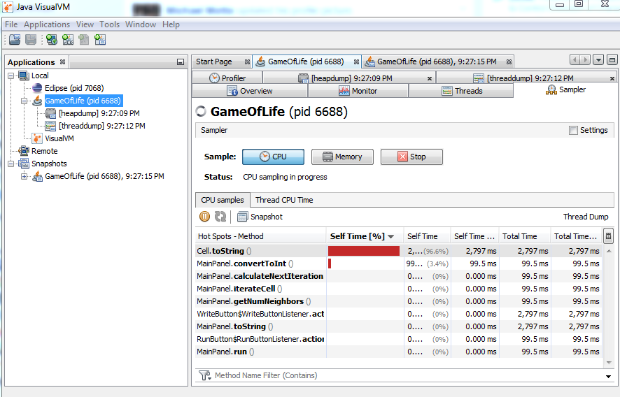

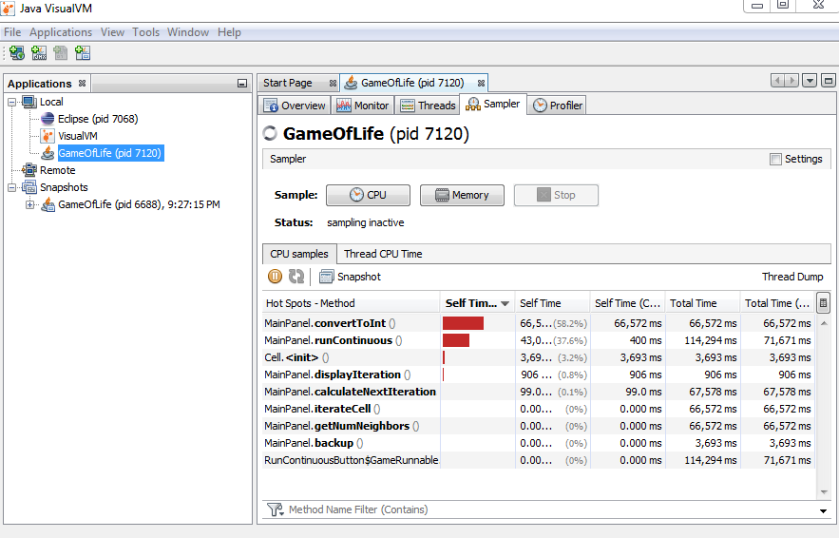

Screenshot After Refactoring 3 Methods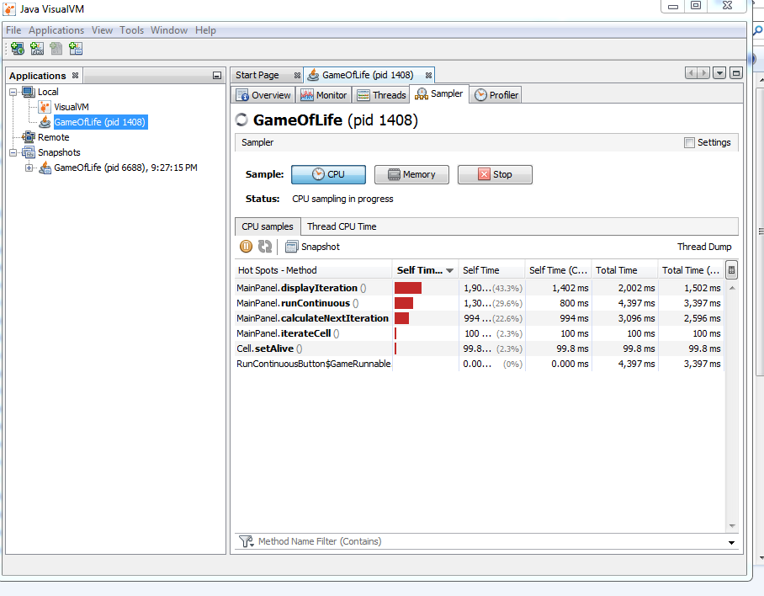

Junit Test Runs

